WEB DEVELOPMENT

AUGUST-2022

MAJOR PROJECT

By : Thatha Anusha

I done this project in visual studio code app.so I recommend to use VS code.

NOTE :: Source code of HTML ,CSS , IMAGE & JS should be save in same folder(same location).

I save HTML code with name weather.html

CSS code with name style.css

and JS code with Backend.js

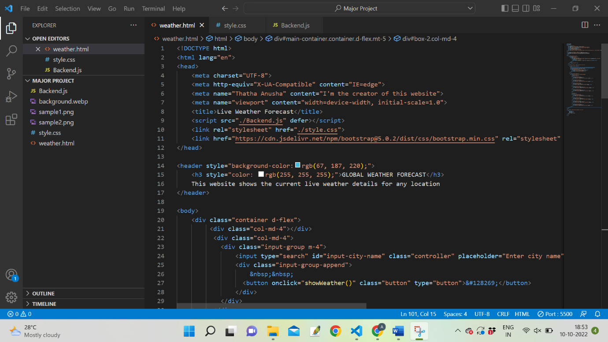

HTML SOURCE CODE :

->copy this html source code into .html file in vs code and name that file as weather

<!DOCTYPE html>

<html lang="en">

<head>

    <meta charset="UTF-8">

    <meta http-equiv="X-UA-Compatible" content="IE=edge">

    <meta name="Thatha Anusha" content="I'm the creator of this website">

    <meta name="viewport" content="width=device-width, initial-scale=1.0">

    <title>Live Weather Forecast</title>

    <script src="./Backend.js" defer></script>

    <link rel="stylesheet" href="./style.css">

    <link href="https://cdn.jsdelivr.net/npm/bootstrap@5.0.2/dist/css/bootstrap.min.css" rel="stylesheet" integrity="sha384-EVSTQN3/azprG1Anm3QDgpJLIm9Nao0Yz1ztcQTwFspd3yD65VohhpuuCOmLASjC" crossorigin="anonymous">

</head>

<header style="background-color:rgb(67, 187, 220);">

    <h3 style="color: rgb(255, 255, 255);">GLOBAL WEATHER FORECAST</h3>

    This website shows the current live weather details for any location

</header>

<body>

    <div class="container d-flex">

         <div class="col-md-4"></div>

          <div class="col-md-4">

            <div class="input-group m-4">

                <input type="search" id="input-city-name" class="controller" placeholder="Enter city name">

                <div class="input-group-append">

                    &nbsp;&nbsp;

                  <button onclick="showWeather()" class="button" type="button">&#128269;</button>

                </div>

            </div>

          </div>

         <div class="col-md-4"></div>

    </div>

    <div id="main-container" class="container d-flex mt-5">

        <div class="col-md-8" id="box-1">

            <br>

            &nbsp;&nbsp;&nbsp;&nbsp;&nbsp;&nbsp;&nbsp;&nbsp;&nbsp;&nbsp;&nbsp;&nbsp;&nbsp;

            &nbsp;&nbsp;&nbsp;&nbsp;&nbsp;&nbsp;&nbsp;&nbsp;&nbsp;&nbsp;&nbsp;&nbsp;

            <img src="background.webp" alt="weather image" >

            <div class="container d-flex">

                <div class="col-md-4" id="temperature">~&#8451;</div>

                <div class="col-md-4" id="city">loading...</div>

                <div class="col-md-4" id="currenttime"></div>

            </div>

        </div>

        <div class="col-md-4" id="box-2">

            <div class="other-details p-4" id="box-2-subdiv">

                <h5>Weather Details</h5>

                <hr>

                <div class="container d-flex">

                    <div class="col-md-6">Humidity</div>

                    <div id="humidity" class="col-md-6 text-center">loading...</div>

                </div>

                <div class="container d-flex">

                    <div class="col-md-6">Pressure</div>

                    <div id="pressure" class="col-md-6 text-center">loading...</div>

                </div>

                <div class="container d-flex">

                    <div class="col-md-6">Wind</div>

                    <div id="wind" class="col-md-6 text-center">loading...</div>

                </div>

                <div class="container d-flex">

                    <div class="col-md-6">description</div>

                    <div id="description" class="col-md-6 text-center">loading...</div>

                </div>

                <div class="container d-flex">

                    <div class="col-md-6">Visibility</div>

                    <div id="visibility" class="col-md-6 text-center">loading...</div>

                </div>

                <br>

                <h5>Location</h5>

                <hr>

                <div class="container d-flex">

                    <div class="col-md-6">Latitude</div>

                    <div id="latitude" class="col-md-6 text-center">loading...</div>

                </div>

                <div class="container d-flex">

                    <div class="col-md-6">Longitude</div>

                    <div id="longitude" class="col-md-6 text-center">loading...</div>

                </div>

                <div class="container d-flex">

                    <div class="col-md-6">Feels like</div>

                    <div id="feels_like" class="col-md-6 text-center">loading...</div>

                </div>

                <div class="container d-flex">

                    <div class="col-md-6">Country</div>

                    <div id="country" class="col-md-6 text-center">loading...</div>

                </div>

            </div>

        </div>

    </div>

</body>

<footer style=" background-color:rgb(67, 187, 220);">

    <h6>

        &nbsp;&nbsp;

        Copyright &#169;

        &nbsp;&nbsp;

        All rights reserved

    </h6>

</footer>

</html>

CSS SOURCE CODE :

->Copy this css source code into .css file in vs code and name that file as style

body{

    background: rgb(0, 0, 0);

    background: linear-gradient(0deg, rgb(250, 250, 247) 0%, rgb(241, 208, 39) 100%);

    height: 100vh;

}

#main-container{

    box-shadow: 8px 50px 102px -33px rgba(0, 0, 0, 0.55);

    -webkit-box-shadow: 8px 50px 102px -33px rgba(0, 0, 0, 0.55);

    -moz-box-shadow: 8px 50px 102px -33px rgba(0, 0, 0, 0.909);

}

#box-1

{

    margin-left: -12px;

}

#box-1 img

{

    width:50%;

    height: 70%;

}

#temperature

{

    position: absolute;

    top: 82%;

    left: 15%;

    font-size: 4rem;

}

#city

{

    position: absolute;

    top: 85%;

    left: 35%;

    font-size: 3rem;

}

#currenttime

{

    position: absolute;

    top: 40%;

    left: 50%;

    font-size: 1rem;

}

(IF this img is used)Save this img at the locaton of html,css,js files and name that img as background.It must be save as background.WEBP

<img src="background.webp" alt="weather image" >



The pdf file doesn’t support .webp img

so use .jpg img and in jpg the round corners are can’t be transparent so it doesn’t look nice.

*( OR )*

(IF this img is used)Save this img at the location of html,css,js files and name as background.It must be saved as background.jpg

<img src="background.jpg" alt="weather image" >



JAVA SCRIPT SOURCE CODE :

->Copy this java script source code into .js file in VS code and name that file as Backend

//set current time

function currentTime() {

    var curTime = new Date();

    document.getElementById("currenttime").innerHTML = curTime.getFullYear()+'&nbsp;&nbsp; '+

                                                       curTime.getHours()+':'+

                                                       curTime.getMinutes()+':'+

                                                       curTime.getSeconds();

    setTimeout(currentTime,1000);

    }

    currentTime();

function showWeather() {

        let displayCityName = document.getElementById("city");

        let inputCityName   = document.getElementById("input-city-name").value;

        let humidity        = document.getElementById("humidity");

        let pressure        = document.getElementById("pressure");

        let wind            = document.getElementById("wind");

        let description     = document.getElementById("description");

        let visibility      = document.getElementById("visibility");

        let latitude        = document.getElementById("latitude");

        let longitude       = document.getElementById("longitude");

        let feels_Like       = document.getElementById("feels_like");

        let country         = document.getElementById("country");

        let temperature     = document.getElementById("temperature");

        let city            = document.getElementById("city");

        //console.log(cityName);

        fetch("https://api.openweathermap.org/data/2.5/weather?q="+inputCityName+"&appid=cd3976f5ec71f105b2d5b57a3986a8da")

        .then(response => response.json())

        .then(data => {

            console.log(data);

            const apiResponse = [

                data["main"]["temp"],

                data["main"]["feels_like"],

                data["main"]["humidity"],

                data["main"]["pressure"],

                data["name"],

                data["coord"]["lat"],

                data["coord"]["lon"],

                data["wind"]["speed"],

                data["sys"]["country"],

                data["visibility"],

                data["weather"]["0"]["description"],

                data["weather"]["0"]["main"]

            ];

                temperature.innerHTML    = (apiResponse[0] -273.15).toFixed(1)+"&#8451;";

                humidity.innerHTML       = apiResponse[2];

                pressure.innerHTML       = apiResponse[3];

                displayCityName.innerHTML= apiResponse[4];

                latitude.innerHTML       = apiResponse[5];

                longitude.innerHTML      = apiResponse[6];

                wind.innerHTML           = apiResponse[7]+" km/hr";

                visibility.innerHTML     = apiResponse[9];

                country.innerHTML        = apiResponse[8];

                description.innerHTML    = apiResponse[10];

                feels_Like.innerHTML     = apiResponse[11];

            })

            .catch(err => alert("Please enter correct city name!"))

    }

SAMPLE PICTURES OF PROJECT

